**Dash Components**



**Objectives**

After completing the lab, you will be able to:

* Work with Dash Callbacks

**Estimated time needed:** 45 minutes

**Dataset Used**

[Airline Reporting Carrier On-Time Performance](https://developer.ibm.com/exchanges/data/all/airline?cm_mmc=Email_Newsletter-_-Developer_Ed%2BTech-_-WW_WW-_-SkillsNetwork-Courses-IBMDeveloperSkillsNetwork-DV0101EN-SkillsNetwork-20297740&cm_mmca1=000026UJ&cm_mmca2=10006555&cm_mmca3=M12345678&cvosrc=email.Newsletter.M12345678&cvo_campaign=000026UJ) dataset from [Data Asset eXchange](https://developer.ibm.com/exchanges/data?cm_mmc=Email_Newsletter-_-Developer_Ed%2BTech-_-WW_WW-_-SkillsNetwork-Courses-IBMDeveloperSkillsNetwork-DV0101EN-SkillsNetwork-20297740&cm_mmca1=000026UJ&cm_mmca2=10006555&cm_mmca3=M12345678&cvosrc=email.Newsletter.M12345678&cvo_campaign=000026UJ&cm_mmc=Email_Newsletter-_-Developer_Ed%2BTech-_-WW_WW-_-SkillsNetwork-Courses-IBMDeveloperSkillsNetwork-DV0101EN-SkillsNetwork-20297740&cm_mmca1=000026UJ&cm_mmca2=10006555&cm_mmca3=M12345678&cvosrc=email.Newsletter.M12345678&cvo_campaign=000026UJ)

# About Skills Network Cloud IDE

This Skills Network Labs Cloud IDE (Integrated Development Environment) provides a hands-on environment in your web browser for completing the course and project-related labs. It utilizes Theia, an open-source IDE platform that can be run on a desktop or on the cloud.  
So far in the course, you have been using Jupyter Notebooks to run your Python code. This IDE provides an alternative for editing and running your Python code. In this lab, you will be using this alternative Python runtime to create and launch your Dash applications.

### Important Notice about this lab environment

Please be aware that sessions for this lab environment are not persisted. When you launch the Cloud IDE, you are presented with a ‘dedicated computer on the cloud’ exclusively for you. This is available to you as long as you are actively working on the labs.

Once you close your session or it is timed out due to inactivity, you are logged off, and this ‘dedicated computer on the cloud’ is deleted along with any files you may have created, downloaded or installed. The next time you launch this lab, a new environment will be created for you.

If you finish only part of the lab and return later, you may have to start from the beginning. So, it is a good idea to plan your time accordingly and finish your labs in a single session.

**Let's start creating dash application**

**Theme**

Extract the average monthly arrival delay time and see how it changes over the year. The year range is from 2010 to 2020.

**Expected Output**

Below is the expected result from the lab. Our dashboard application consists of three components:

* Title of the application
* Component to enter input year
* Chart conveying the average monthly arrival delay

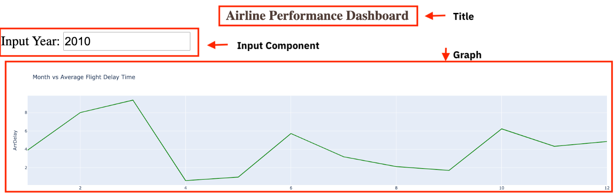

**Tasks To do:**

1. Task 1
   * Import required libraries
   * Read the dataset
2. Task 2
   * Create an application layout
   * Add title to the dashboard application using HTML H1 component
3. Task 3
   * Add input text box using core input and output components
   * Add the callback decorator and generate the line chart within the callback function.
4. Task 4
   * Practice Exercise

**Get the tool ready**

* Install python packages required to run the application. Copy and paste the below command to the terminal.

1. 1
2. python3 -m pip install packaging

Copied!

1. 1
2. python3 -m pip install pandas dash

Copied!

1. 1
2. pip3 install httpx==0.20 dash plotly

Copied!

* Create a new python script, by clicking on the menu bar and selecting **File**->**New File**, as in the image below.

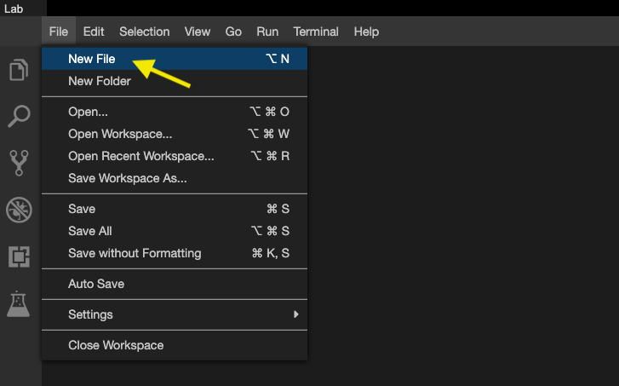

* Provide the file name as dash_interactivity.py

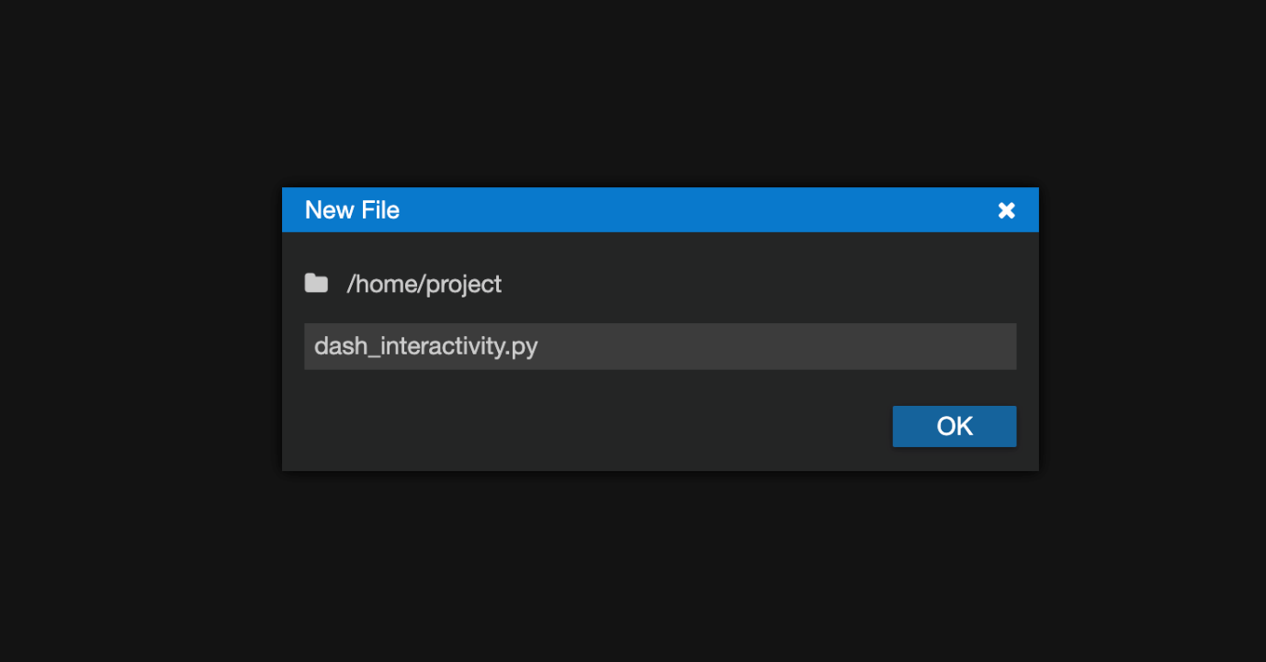

* Open a new terminal by clicking on the menu bar and selecting **Terminal**->**New Terminal**, as in the image below.

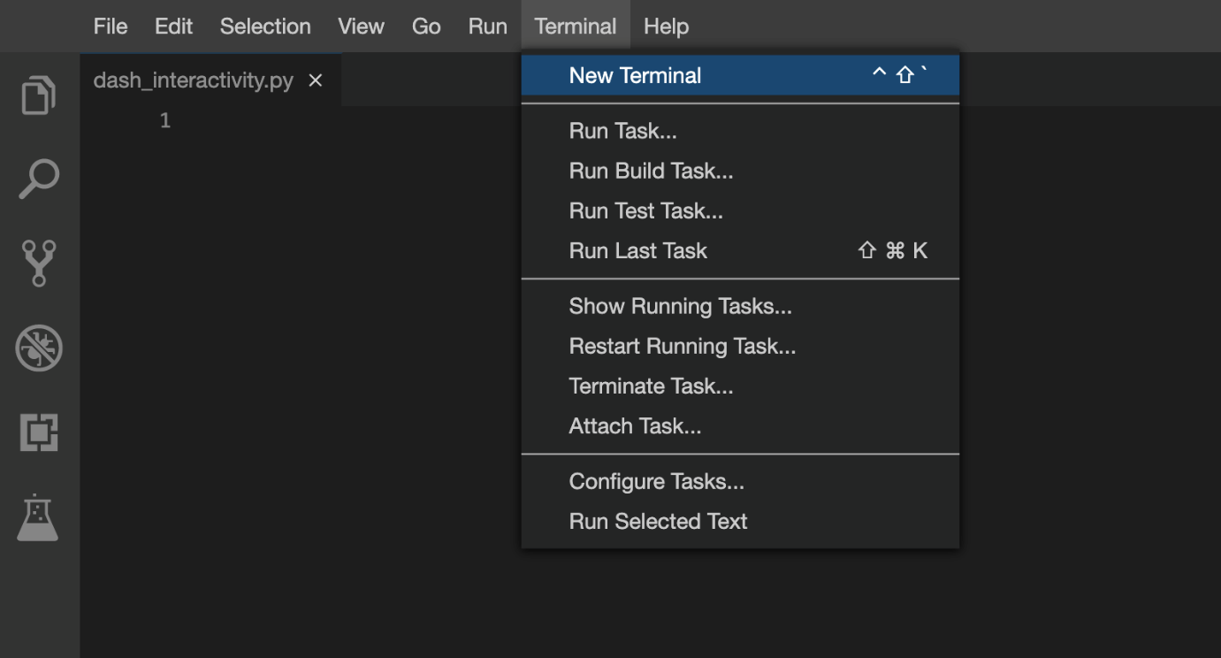

* Now, you have script and terminal ready to start the lab.

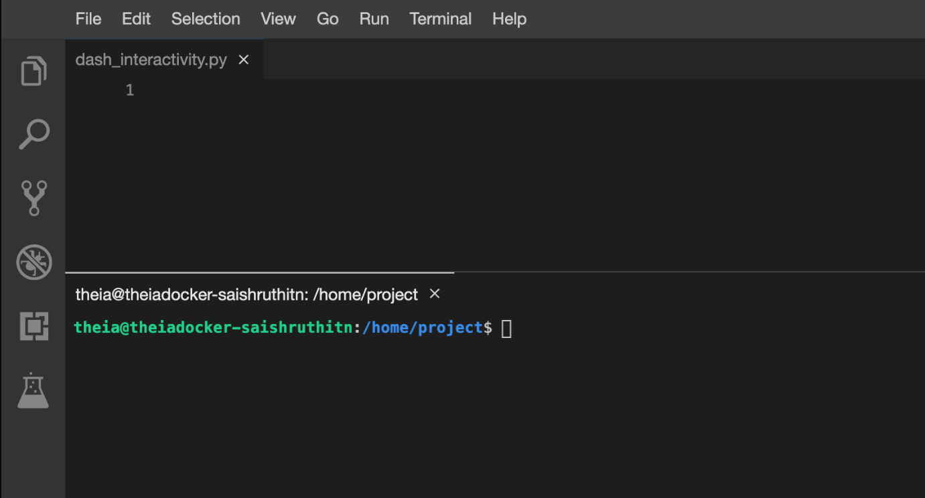

**TASK 1 - Read the data**

Here you will be:

* Importing necessary libraries
* Reading the data from a CSV file

In this exercise we require the following libraries :

* pandas
* plotly
* dash
* dash_html_components
* dash_core_components
* dash.dependencies

We will first import these libraries

1. 1
2. 2
3. 3
4. 4
5. 5
6. 6
7. import pandas as pd
8. import plotly.graph_objects as go
9. import dash
10. import dash_html_components as html
11. import dash_core_components as dcc
12. from dash.dependencies import Input, Output

Copied!

Now we will read the dataset using the pd.read_csv() function.

1. 1
2. 2
3. 3
4. 4
5. airline_data = pd.read_csv('https://cf-courses-data.s3.us.cloud-object-storage.appdomain.cloud/IBMDeveloperSkillsNetwork-DV0101EN-SkillsNetwork/Data%20Files/airline_data.csv',
6. encoding = "ISO-8859-1",
7. dtype={'Div1Airport': str, 'Div1TailNum': str,
8. 'Div2Airport': str, 'Div2TailNum': str})

Copied!

* The above code reads a CSV file called **airline_data.csv** from a URL using pandas, a popular data analysis library in Python.
* The file is encoded using ISO-8859-1 character encoding, which is a standard way of representing characters in the file.
* We defined data type of specific columns such as (Div1Airport, Div1TailNum, Div2Airport, and Div2TailNum) to be strings, which ensures that these columns are read as text instead of numbers.
* The resulting data is stored in a pandas dataframe object called airline_data, which can be used for further analysis.

Copy the below code to the dash_interactivity.py script and review the code.

1. 1
2. 2
3. 3
4. 4
5. 5
6. 6
7. 7
8. 8
9. 9
10. 10
11. 11
12. 12
13. 13
14. # Import required libraries
15. import pandas as pd
16. import plotly.graph_objects as go
17. import dash
18. import dash_html_components as html
19. import dash_core_components as dcc
20. from dash.dependencies import Input, Output
21. # Read the airline data into the pandas dataframe
22. airline_data = pd.read_csv('https://cf-courses-data.s3.us.cloud-object-storage.appdomain.cloud/IBMDeveloperSkillsNetwork-DV0101EN-SkillsNetwork/Data%20Files/airline_data.csv',
23. encoding = "ISO-8859-1",
24. dtype={'Div1Airport': str, 'Div1TailNum': str,
25. 'Div2Airport': str, 'Div2TailNum': str})

Copied!

Now save and run this code.

Copy and paste the below command in the terminal to run the code.

1. 1
2. python3 dash_interactivity.py

Copied!

After running the above code you can see the below-expected output:

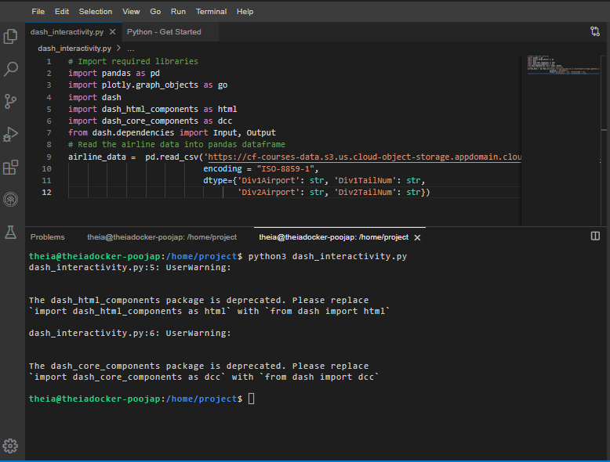

# TASK 2 - Create dash application and get the layout

Next, we create a skeleton for our dash application. Overall this layout creates a simple container with a heading, an input field, and some empty space.

In the upcoming tasks, you can modify and add new components and styles to the basic layout provided. This will allow you to customize and enhance the user interface of your Dash app to meet your specific needs and requirements as follows:

* First we will define an application app.layout.
* Create a heading using html.h1() and add style information within the divison html.Div().
* create a inner division using html.Div() function for adding input and output components such as:
  + Input: label, dropdown input-year and style parameters
  + Output: type of Graph line-plot

1. 1
2. 2
3. 3
4. 4
5. 5
6. 6
7. 7
8. 8
9. 9
10. 10
11. 11
12. 12
13. 13
14. 14
15. # Create a dash application layout
16. app = dash.Dash(__name__)
17. # Get the layout of the application and adjust it.
18. # Create an outer division using html.Div and add title to the dashboard using html.H1 component
19. # Add a html.Div and core input text component
20. # Finally, add graph component.
21. app.layout = html.Div(children=[html.H1(),
22. html.Div(["Input Year", dcc.Input(),],
23. style={}),
24. html.Br(),
25. html.Br(),
26. html.Div(),
27. ])

Copied!

## Mapping to the respective Dash HTML tags:

### Application title add using html.H1() tag

* Heading reference: [Plotly H1 HTML Component](https://dash.plotly.com/dash-html-components/h1)
* Title as Airline Performance Dashboard
* Use style parameter for the title and make it center aligned, with color code #503D36, and font-size as 40. Check More about HTML section [here](https://dash.plotly.com/layout).

NOTE: After adding the components, you code will look like the below code.(You can copy dash application code to dash_interactivity.py script and run)

1. 1
2. 2
3. 3
4. 4
5. 5
6. 6
7. 7
8. 8
9. 9
10. 10
11. 11
12. 12
13. 13
14. 14
15. 15
16. 16
17. 17
18. 18
19. 19
20. 20
21. 21
22. 22
23. 23
24. 24
25. 25
26. 26
27. 27
28. # Import required libraries
29. import pandas as pd
30. import plotly.graph_objects as go
31. import dash
32. import dash_html_components as html
33. import dash_core_components as dcc
34. from dash.dependencies import Input, Output
35. # Read the airline data into pandas dataframe
36. airline_data = pd.read_csv('https://cf-courses-data.s3.us.cloud-object-storage.appdomain.cloud/IBMDeveloperSkillsNetwork-DV0101EN-SkillsNetwork/Data%20Files/airline_data.csv',
37. encoding = "ISO-8859-1",
38. dtype={'Div1Airport': str, 'Div1TailNum': str,
39. 'Div2Airport': str, 'Div2TailNum': str})
41. # Create a dash application
42. app = dash.Dash(__name__)
43. app.layout = html.Div(children=[html.H1('Airline Performance Dashboard',style={'textAlign': 'center', 'color': '#503D36', 'font-size': 40}),
44. html.Div(["Input Year", dcc.Input(),],
45. style={}),
46. html.Br(),
47. html.Br(),
48. html.Div(),
49. ])
50. # Run the app
51. if __name__ == '__main__':
52. app.run_server()

Copied!

## To run the Dash app follow the below steps

* First, install pandas and dash using the following command in the terminal

1. 1
2. pip3 install pandas dash

Copied!

* Copy and paste the below command in the terminal to run the application.

1. 1
2. python3 dash_interactivity.py

Copied!

* Observe the port number shown in the terminal.

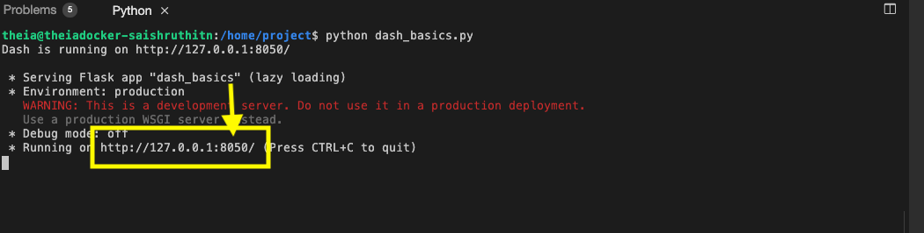

* Click on the Launch Application option from the side menu bar.Provide the port number and click OK

The app will open in a new browser tab like below:

After running the above code, launch the app in a new tab and below is the expected result from the code:

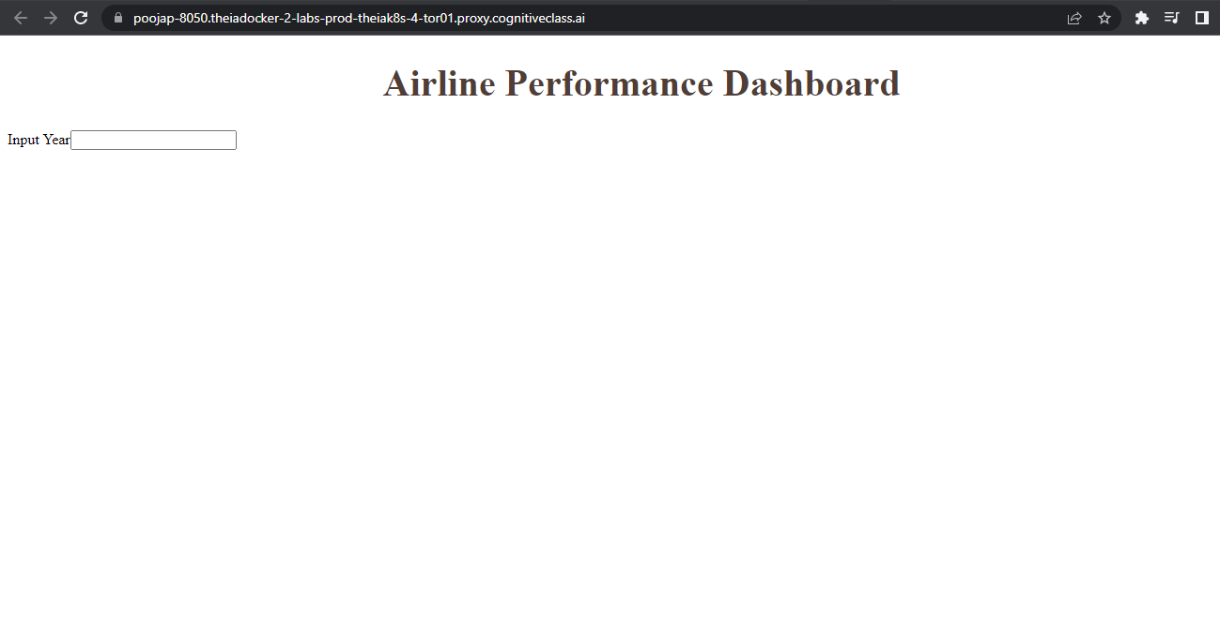

**Input and Output components of layout**

**Input component**

* As our input is a dropdown showing a list of years we will use the [dcc.Input()](https://dash.plotly.com/dash-core-components/input) function. We define the following parameters
  + id: input-year, which is a unique identifier for this specific input field. The default value for this input field will be set to 2010, and the type of input will be a number.
* style parameter for the dropdown: Here within it we define’heightof the input box to be50pxandfont-sizeto be35` to make the text larger and more readable.
* style parameter for the whole division: Now assign font-size as 40 .

**Output component**

* Add dcc.Graph() component to the second division.
* Update [dcc.Graph](https://dash.plotly.com/dash-core-components/graph) component id as line-plot.

*NOTE*: After adding the componenets you code will look like below code.(You can copy dash application code to dash_interactivity.py script and run).

**To terminate a currently running program in the Python terminal (also known as the Python REPL), you can use the KeyboardInterrupt shortcut. This can be done by pressing the CTRL and C keys simultaneously.**

1. 1
2. 2
3. 3
4. 4
5. 5
6. 6
7. 7
8. 8
9. 9
10. 10
11. 11
12. 12
13. 13
14. 14
15. 15
16. 16
17. 17
18. 18
19. 19
20. 20
21. 21
22. 22
23. 23
24. 24
25. 25
26. 26
27. 27
28. # Import required libraries
29. import pandas as pd
30. import plotly.graph_objects as go
31. import dash
32. import dash_html_components as html
33. import dash_core_components as dcc
34. from dash.dependencies import Input, Output
35. # Read the airline data into pandas dataframe
36. airline_data = pd.read_csv('https://cf-courses-data.s3.us.cloud-object-storage.appdomain.cloud/IBMDeveloperSkillsNetwork-DV0101EN-SkillsNetwork/Data%20Files/airline_data.csv',
37. encoding = "ISO-8859-1",
38. dtype={'Div1Airport': str, 'Div1TailNum': str,
39. 'Div2Airport': str, 'Div2TailNum': str})
40. # Create a dash application
41. app = dash.Dash(__name__)
43. app.layout = html.Div(children=[ html.H1('Airline Performance Dashboard',style={'textAlign': 'center', 'color': '#503D36', 'font-size': 40}),
44. html.Div(["Input Year: ", dcc.Input(id='input-year', value='2010',
45. type='number', style={'height':'50px', 'font-size': 35}),],
46. style={'font-size': 40}),
47. html.Br(),
48. html.Br(),
49. html.Div(dcc.Graph(id='line-plot')),
50. ])
51. # Run the app
52. if __name__ == '__main__':
53. app.run_server()

Copied!

After running the above code, launch the app in a new tab and below is the expected result from the code:

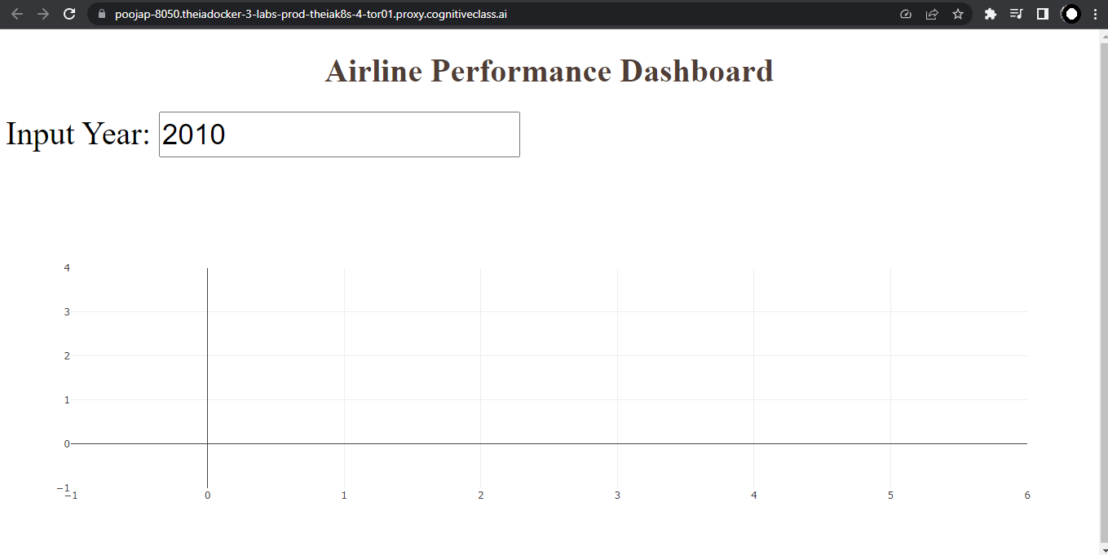

# TASK 3 - Add the application callback function

## Callback

In Python, **@app.callback** is a decorator used in the Dash framework to specify that a function should be called when an input component changes its value.The Input and Output functions are used to define the inputs and outputs of a callback function.

The core idea of this application is to get year as user input(input function) and update the dashboard(output function) in real-time with the help of callback function.

Steps:

* Define the callback decorator
* Define the callback function that uses the input provided to perform the computation
* Create graph and return it as an output

The below code is base structure for calback decorator and function graph.

1. 1
2. 2
3. 3
4. 4
5. 5
6. 6
7. 7
8. 8
9. 9
10. 10
11. 11
12. 12
13. 13
14. 14
15. 15
16. 16
17. 17
18. 18
19. 19
20. 20
21. # add callback decorator
22. @app.callback(Output(),
23. Input())
24. # Add computation to callback function and return graph
25. def get_graph(entered_year):
26. # Select data based on the entered year
27. df = airline_data[airline_data['Year']==int(entered_year)]
29. # Group the data by Month and compute the average over arrival delay time.
30. line_data = df.groupby('Month')['ArrDelay'].mean().reset_index()
32. #
33. fig = go.Figure(data=)
34. fig.update_layout()
35. return fig
36. # Run the app
37. if __name__ == '__main__':
38. app.run_server()

**Update the callback function**

**Callback decorator**

* Refer to examples provided [here](https://dash.plotly.com/basic-callbacks)
* Input() function takes two parameters:
  + component-id with the value input-year, which is the ID of the input dropdown.
  + component_property being accessed is the value property, which represents the year entered by the user.
* Output()function takes two parameters:
  + component-id with the value line-plot, which is the id of the output.
  + component_property being modified is the figure property, which specifies the data and layout of the line plot.

**Callback function**

* Update data parameter of the go.Figure() with the scatter plot. Refer [here](https://plotly.com/python/line-and-scatter/#scatter-and-line-plot-with-goscatter). Sample syntax below:

1. 1
2. go.Scatter(x='----', y='----', mode='-----', marker='----)

Copied!

In the go.Scatter() update the parameter as below:

* Update x as line_data['Month']
* Update y as line_data['ArrDelay']
* Update mode as lines, and marker as dict(color='green')
* Update fig.update_layout with title, xaxis_title, and yaxis_title parameters.
  + Title as Month vs Average Flight Delay Time
  + xaxis_title as Month
  + yaxis_title as ArrDelay  
    Refer the updated layout function [here](https://plotly.com/python/line-and-scatter/#style-scatter-plots).

Refer to the full python code of dash_interactivity.py below:

1. 1
2. 2
3. 3
4. 4
5. 5
6. 6
7. 7
8. 8
9. 9
10. 10
11. 11
12. 12
13. 13
14. 14
15. 15
16. 16
17. 17
18. 18
19. 19
20. 20
21. 21
22. 22
23. 23
24. 24
25. 25
26. 26
27. 27
28. 28
29. 29
30. 30
31. 31
32. 32
33. 33
34. 34
35. 35
36. 36
37. 37
38. 38
39. 39
40. 40
41. 41
42. 42
43. 43
44. 44
45. 45
46. # Import required libraries
47. import pandas as pd
48. import plotly.graph_objects as go
49. import dash
50. import dash_html_components as html
51. import dash_core_components as dcc
52. from dash.dependencies import Input, Output
53. # Read the airline data into the pandas dataframe
54. airline_data = pd.read_csv('https://cf-courses-data.s3.us.cloud-object-storage.appdomain.cloud/IBMDeveloperSkillsNetwork-DV0101EN-SkillsNetwork/Data%20Files/airline_data.csv',
55. encoding = "ISO-8859-1",
56. dtype={'Div1Airport': str, 'Div1TailNum': str,
57. 'Div2Airport': str, 'Div2TailNum': str})
58. # Create a dash application
59. app = dash.Dash(__name__)
61. app.layout = html.Div(children=[ html.H1('Airline Performance Dashboard',style={'textAlign': 'center', 'color': '#503D36', 'font-size': 40}),
62. html.Div(["Input Year: ", dcc.Input(id='input-year', value='2010',
63. type='number', style={'height':'50px', 'font-size': 35}),],
64. style={'font-size': 40}),
65. html.Br(),
66. html.Br(),
67. html.Div(dcc.Graph(id='line-plot')),
68. ])
69. # add callback decorator
70. @app.callback( Output(component_id='line-plot', component_property='figure'),
71. Input(component_id='input-year', component_property='value'))
72. # Add computation to callback function and return graph
73. def get_graph(entered_year):
74. # Select 2019 data
75. df = airline_data[airline_data['Year']==int(entered_year)]
77. # Group the data by Month and compute average over arrival delay time.
78. line_data = df.groupby('Month')['ArrDelay'].mean().reset_index()
79. fig = go.Figure(data=go.Scatter(x=line_data['Month'], y=line_data['ArrDelay'], mode='lines', marker=dict(color='green')))
80. fig.update_layout(title='Month vs Average Flight Delay Time', xaxis_title='Month', yaxis_title='ArrDelay')
81. return fig
82. # Run the app
83. if __name__ == '__main__':
84. app.run_server()

Copied!

After running the above code, launch the app in a new tab and below is the expected final result from the code:

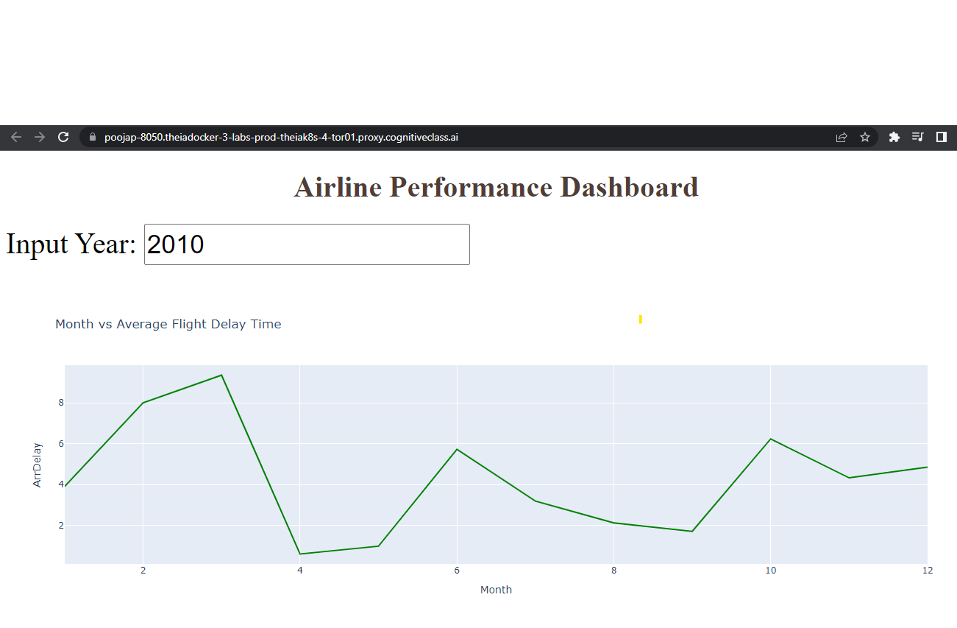

# TASK 4 : Practice Exercise

## You will practice some tasks to create the new dashboard.

***Note***: Please refer the Bar chart exercise of [Plotly basics: scatter, line, bar, bubble, histogram, pie, sunburst](https://www.coursera.org/learn/python-for-data-visualization/ungradedLti/OrxCy/plotly-basics-scatter-line-bar-bubble-histogram-pie-sunburst) lab for this exercise.

### Theme

Let us use a bar chart to extract the number of flights from a specific airline that goes to a destination.

#### Expected Output

Below is the expected result from the lab. Our dashboard application consists of three components:

* Title of the application
* Component to enter input year
* A chart conveying Total number of flights to the destination state.

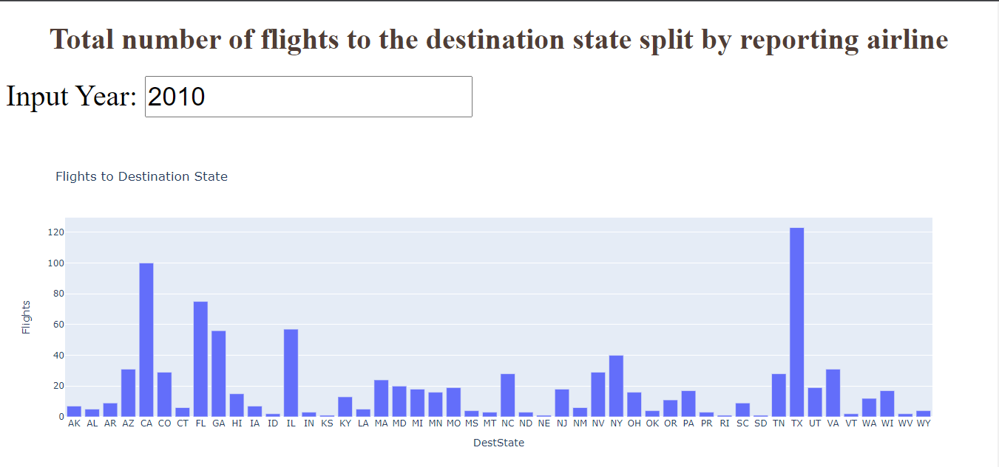

Create a new python script and provide the file name as dash_interactivity_barplot.py.

1. *Import all the required libraries and read the*[*Airline Reporting Carrier On-Time Performance*](https://developer.ibm.com/exchanges/data/all/airline?cm_mmc=Email_Newsletter-_-Developer_Ed%2BTech-_-WW_WW-_-SkillsNetwork-Courses-IBMDeveloperSkillsNetwork-DV0101EN-SkillsNetwork-20297740&cm_mmca1=000026UJ&cm_mmca2=10006555&cm_mmca3=M12345678&cvosrc=email.Newsletter.M12345678&cvo_campaign=000026UJ)*dataset.*

Answer

1. *Give the title to the dashboard to “Total number of flights to the destination state split by reporting air” using HTML H1 component and font-size as 50.*
   1. **Input component** Make changes to a component called dcc.Input in a tool called Dash. We are updating its id to be input-year, which is a unique identifier for this specific input field. The default value for this input field will be set to 2010, and the type of input will be a number.

To make the text larger and more readable, use the style parameter and assign the height of the input box to 50px and font-size to be 35. Use style parameter again and assign font-size of 40 for the whole division

* 1. **Output component**Add dcc.Graph() component to the second division. Update dcc.Graph component id as bar-plot.

Answer

1. ***Add Callback decorator***
   1. Update **output** component id parameter with bar-plot same as the id provided in the dcc.Graph() component and component property as figure.
   2. Update **input** component id parameter with input-year same as the id provided in the dcc.Input() component and component property as value.

*Use style parameter and assign font-size as 35 for the whole division.*

1. Answer
2. ***Define Callback graph function***
   1. Group the data by destination state and reporting airline. Compute the total number of flights in each combination
   2. Use plotly express bar chart function px.bar. Provide input data, x and y axis variables, and a chart title. This will give the total number of flights to the destination state

Answer

1. *Add the code for running the app, save the above changes, and relaunch the dashboard application to see the new dashboard.*

Answer

### Congratulations, you have successfully created your dash application!

## Author

[Saishruthi Swaminathan](https://www.linkedin.com/in/saishruthi-swaminathan?cm_mmc=Email_Newsletter-_-Developer_Ed%2BTech-_-WW_WW-_-SkillsNetwork-Courses-IBMDeveloperSkillsNetwork-DV0101EN-SkillsNetwork-20297740&cm_mmca1=000026UJ&cm_mmca2=10006555&cm_mmca3=M12345678&cvosrc=email.Newsletter.M12345678&cvo_campaign=000026UJ)

## Changelog

| **Date** | **Version** | **Changed by** | **Change Description** |
| --- | --- | --- | --- |
| 05-07-2021 | 1.0 | Saishruthi | Initial version created |
| 24-08-2022 | 1.1 | Pratiksha | Instructions updated |
| 29-08-2022 | 1.2 | Pratiksha Verma | Updated Screenshot |
| 12-04-2023 | 1.3 | Pooja Patel | Updated instructions and Screenshot |
| 06-07-2023 | 1.4 | Dr. Pooja | Updated code |

### © IBM Corporation 2020. All rights reserved.